He was our first child. Like any parents, we had big hopes and dreams for him: a good education, lots of friends and a happy life! But it soon became apparent that he was ‘different’: no eye contact, no speech and lots of tantrums. At age 3, we received the autism diagnosis that altered all our dreams. As parents, we were faced with two choices: accept the poor prognosis of the diagnosing paediatrician that “he may never talk; he may never read or write” and the accompanying ‘wait and see’ provision or do something different that offered hope. We chose the latter and decided to try applied behaviour analysis (ABA) on a ‘budget’ where the parents are also the therapists.

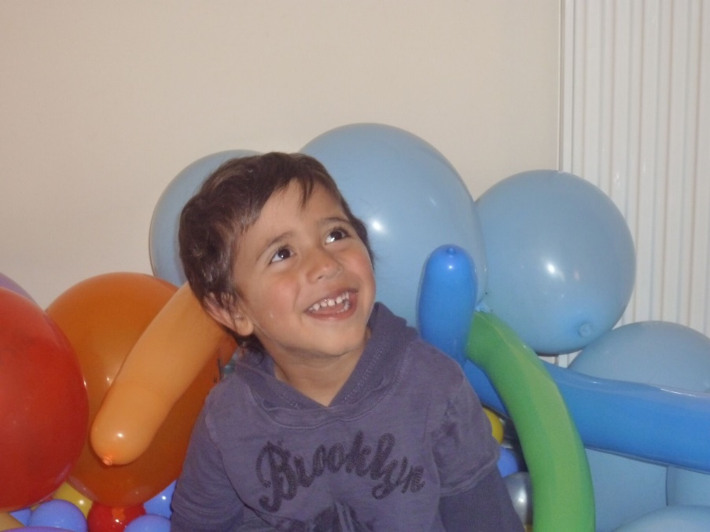
Within few weeks of ABA, my son was able to answer simple yes/no questions and we were able to navigate his needs and wants. Few weeks later, we recruited a tutor to help, and he learned to ask for things he wanted and needed; e.g. a biscuit, water, a toy etc. Through lots of love, perseverance and hard work our lives (especially his) improved for the better. By age 4, he learned the necessary skills that allowed him to join a mainstream school with continued 1-1 ABA support at home in the afternoons. With every word, every smile, every skill learned, his confidence, his horizons and our hopes grew. And as an additional bonus, he thoroughly enjoyed his ABA sessions and loved his therapists (who subsequently became part of the family). This is what he remembers about the early intervention: “J worked with me for about 2–4 hours, for example she showed me laminated pictures and I had to work out how to describe these images…it’s all blurred now because that was 6 years ago, but it was really fun especially the picnics that we had every day after that (now not too hard) work…I think she was one of the reasons I passed the 11+.”

Despite the initial poor prognosis, our son now attends one of the best grammar schools in the country. We couldn’t be happier. Of course, the autism is still there; navigating the social word is still difficult, but we believe in him and he believes in himself. We just hope and wish that kids with autism are not written off early in life. Every child should be entitled to the right intervention that would unlock their full potential and help them thrive. Our son is now learning to code and aims to make his own ‘kid-friendly’ chat app, especially to help children with difficulties, that would automatically block any bullying and alert the parents. He also wants to join Microsoft…one day…

